Introduction to Database Systems – Lab

Nested Queries and JOIN

Use bank schema

1. Display the customers' name and phone number along with their current credit which is greater than 15000 by using INNER JOIN.

select customer.name, customer.phonenum, loanaccounts.current_credit

from customer

inner join loanaccounts on customer.customer_id = loanaccounts.customer_id

where loanaccounts.current_credit > 15000;

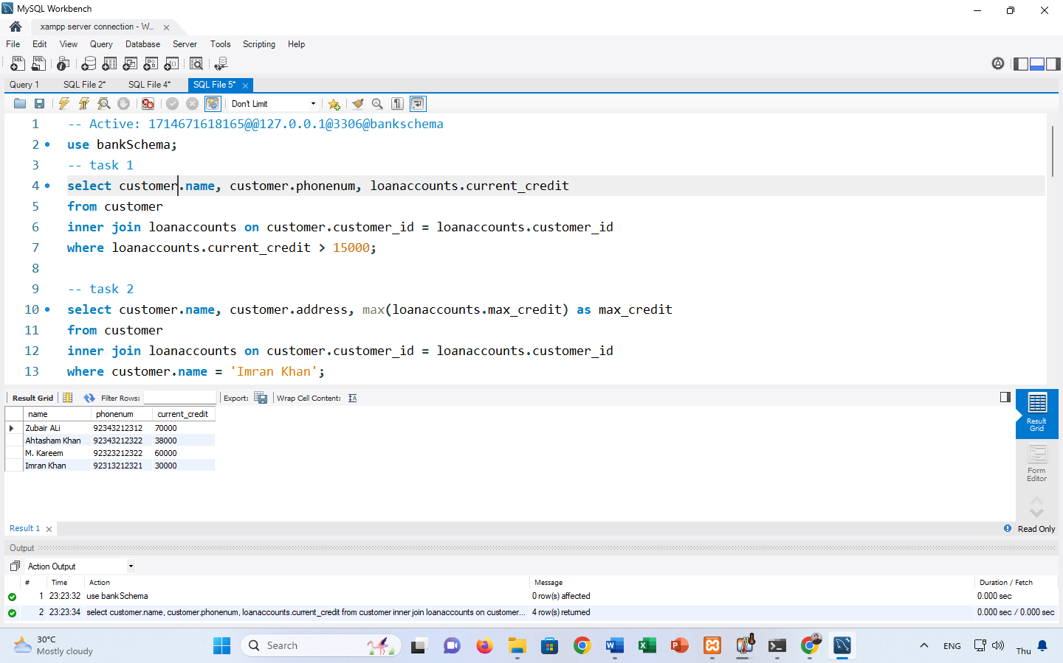

2. Display customer's name and address along with the maximum credit of the customer whose name is Imran Khan.

select customer.name, customer.address, max(loanaccounts.max_credit) as max_credit

from customer

inner join loanaccounts on customer.customer_id = loanaccounts.customer_id

where customer.name = 'Imran Khan';  
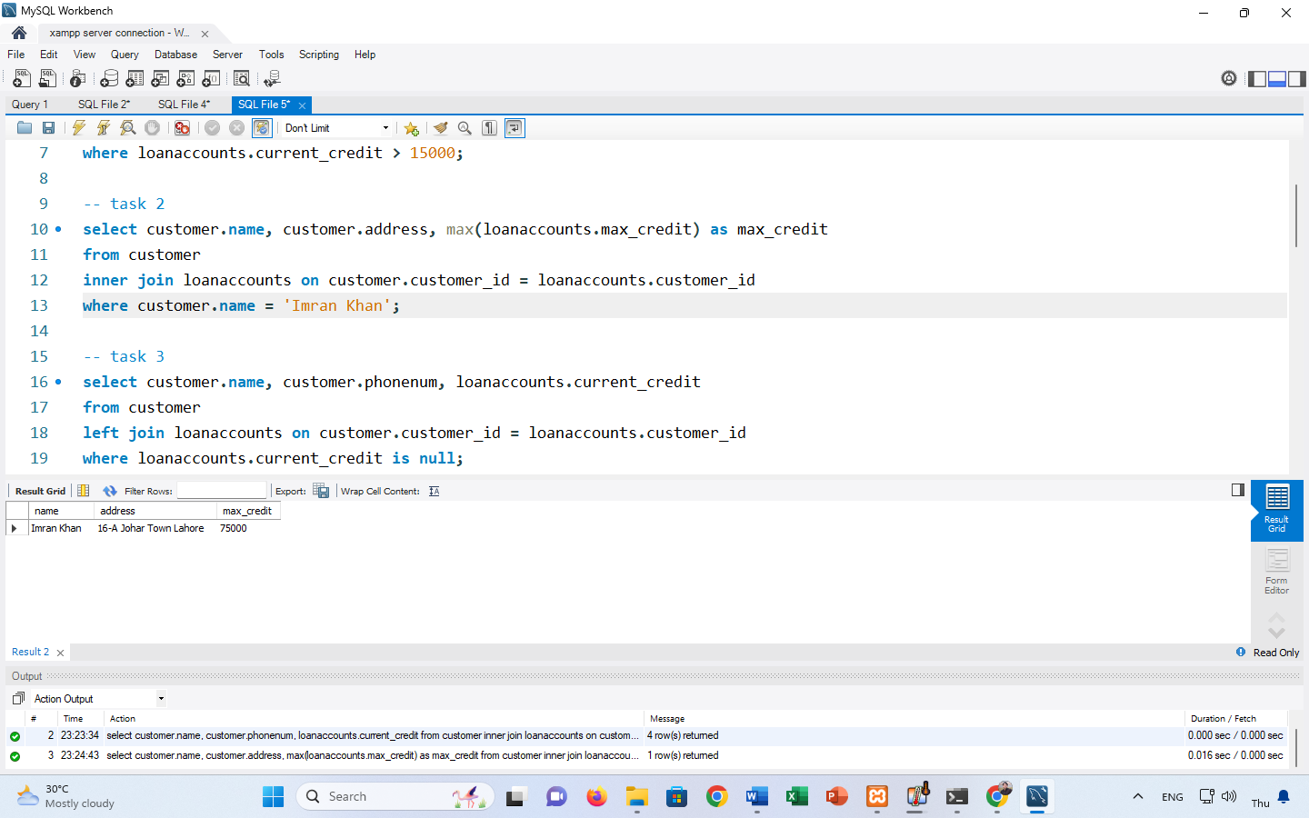

3. Display the names, phone numbers and current credit of those customers whose current credit is NULL by using LEFT JOIN.

select customer.name, customer.phonenum, loanaccounts.current_credit

from customer

left join loanaccounts on customer.customer_id = loanaccounts.customer_id

where loanaccounts.current_credit is null;

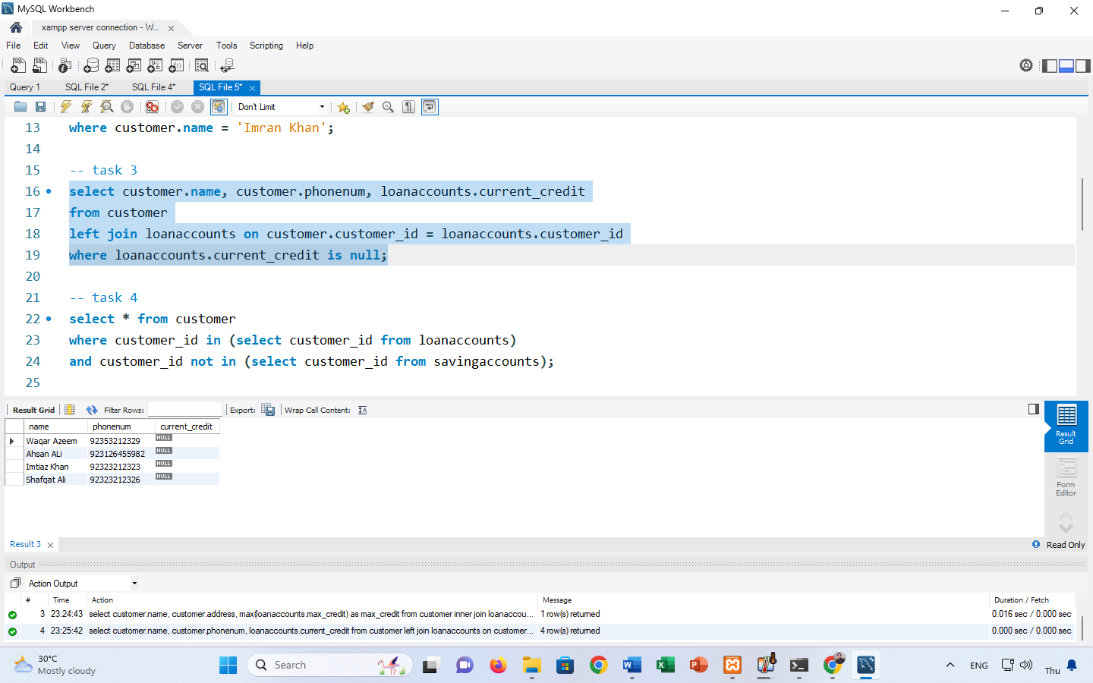

4. Display the complete data of those customers who have applied for loan but not for the saving accounts by using IN and NOT commands.

select * from customer

where customer_id in (select customer_id from loanaccounts)

and customer_id not in (select customer_id from savingaccounts);

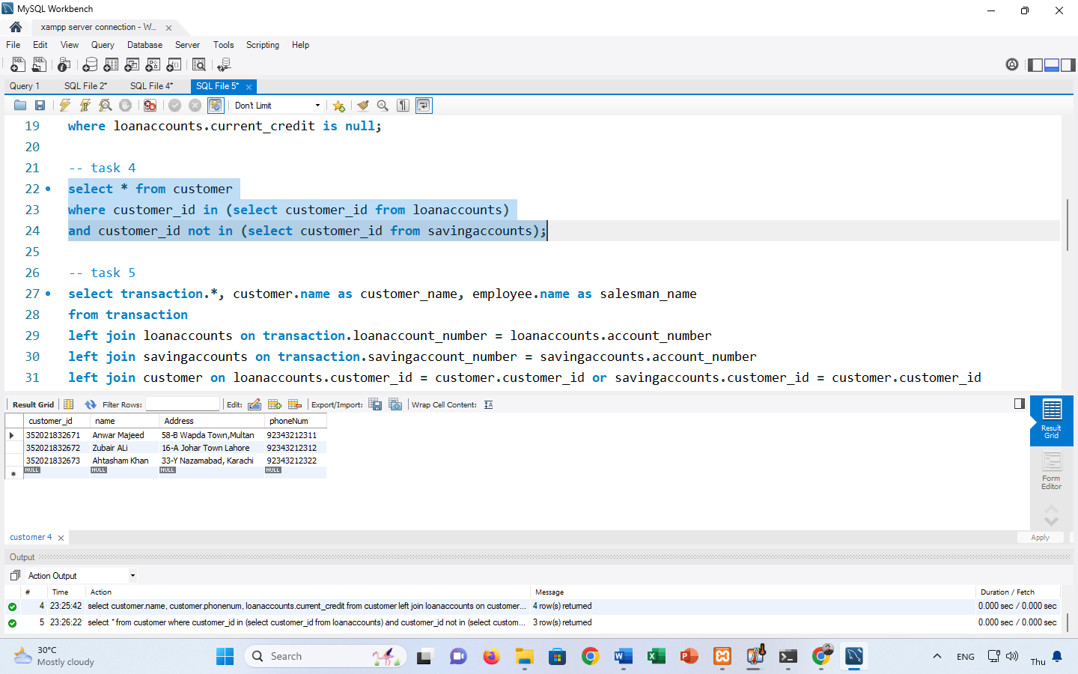

5. Display the complete record of the transaction made by the customer along with the customer Name and the Salesman Name

select transaction.*, customer.name as customer_name, employee.name as salesman_name

from transaction

left join loanaccounts on transaction.loanaccount_number = loanaccounts.account_number

left join savingaccounts on transaction.savingaccount_number = savingaccounts.account_number

left join customer on loanaccounts.customer_id = customer.customer_id or savingaccounts.customer_id = customer.customer_id

left join employee on transaction.eid = employee.eid;

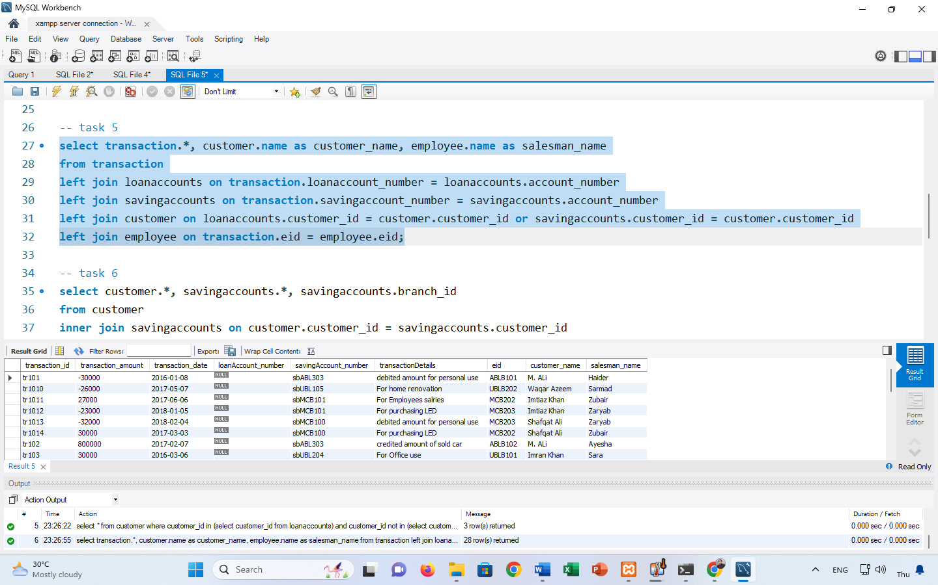

6. By using IN command display the complete record of customers and the record of their saving accounts along with the branch id of the bank.

select customer.*, savingaccounts.*, savingaccounts.branch_id

from customer

inner join savingaccounts on customer.customer_id = savingaccounts.customer_id

where customer.customer_id in (select customer_id from savingaccounts);

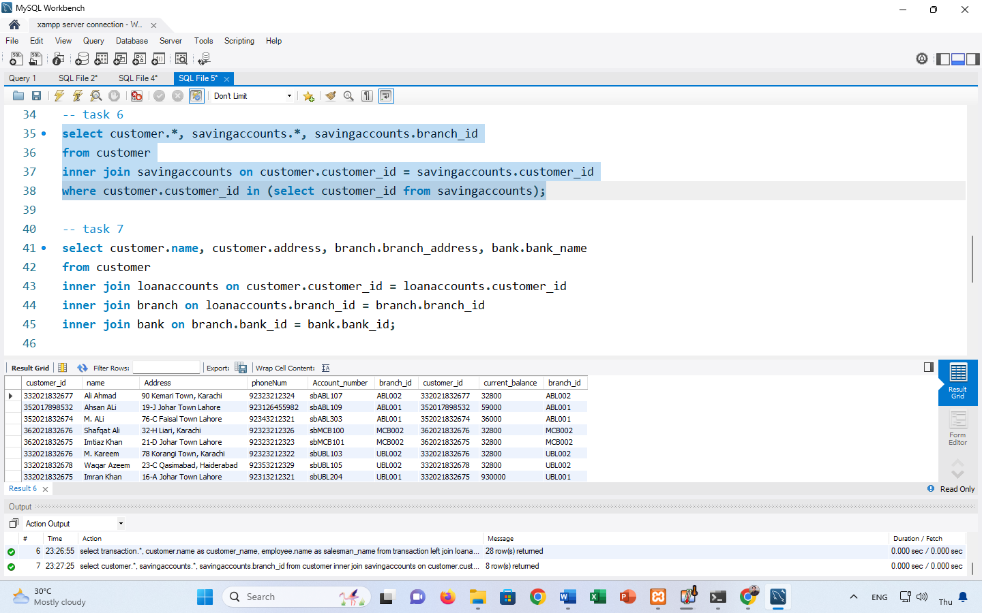

7. Display the name and address of the customers along with their branch address and bank name;

select customer.name, customer.address, branch.branch_address, bank.bank_name

from customer

inner join loanaccounts on customer.customer_id = loanaccounts.customer_id

inner join branch on loanaccounts.branch_id = branch.branch_id

inner join bank on branch.bank_id = bank.bank_id;

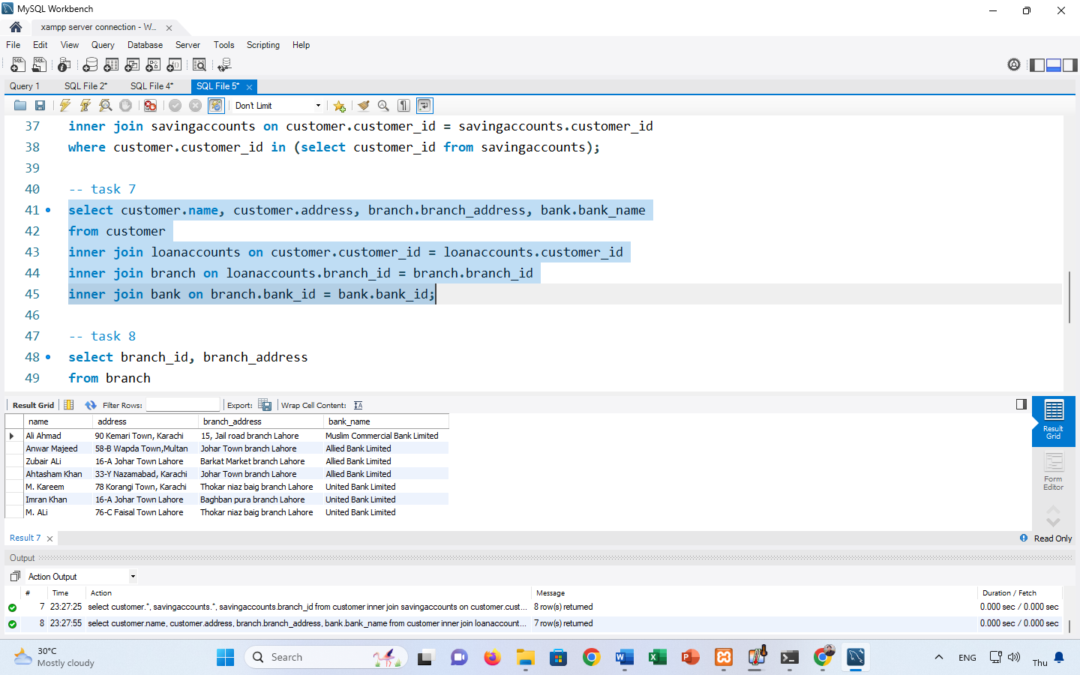

8. Display the branch id and branch address of the Allied Bank Limited by using IN command;

select branch_id, branch_address

from branch

where bank_id in (select bank_id from bank where bank_name = 'Allied Bank Limited');



9. Display the names, designations of the employees along with their branch address and bank name by using multiple RIGHT JOINS.

select employee.name, employee.designation, branch.branch_address, bank.bank_name

from employee

right join branch on employee.branch_id = branch.branch_id

right join bank on branch.bank_id = bank.bank_id;

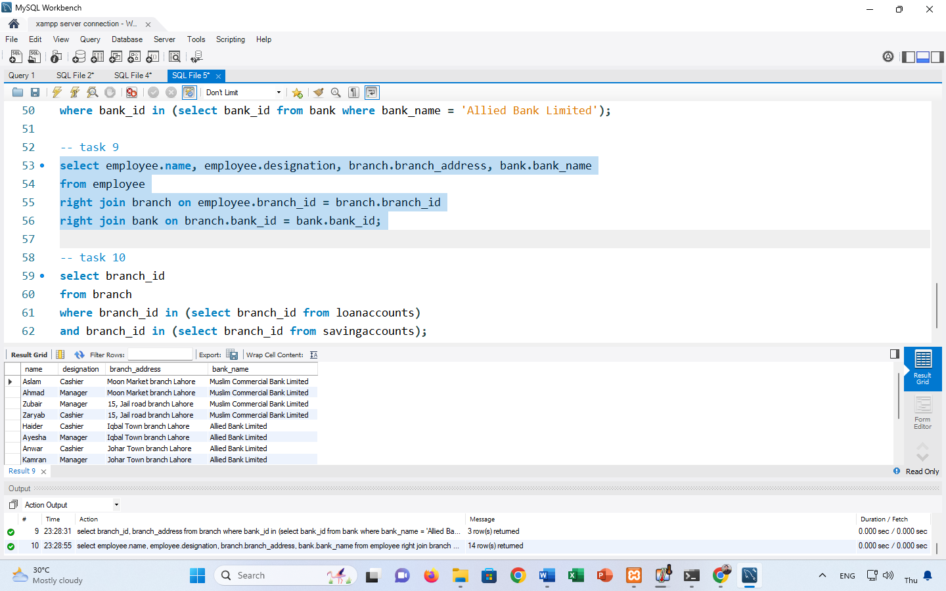

10. Display the branch id of those branches which have assigned loan accounts and saving accounts to the customers by using multiple IN commands.

select branch_id

from branch

where branch_id in (select branch_id from loanaccounts)

and branch_id in (select branch_id from savingaccounts);

